Develop a python Script

|  |  |
| --- | --- |
| Date | 15 November 2022 |
| Team ID | PNT2022TMID29155 |
| Project Name | Project-Signs with smart connectivity for better road safety |
| Maximum Marks | 4 Marks |

**Create a code snippet using python compiler**

1. Extract weather data from Open Weather Map using APIs
2. Send the extracted data to the cloud
3. Receive data from the cloud and view it in the python compiler
4. **Extract weather data from Open Weather Map using APIs**

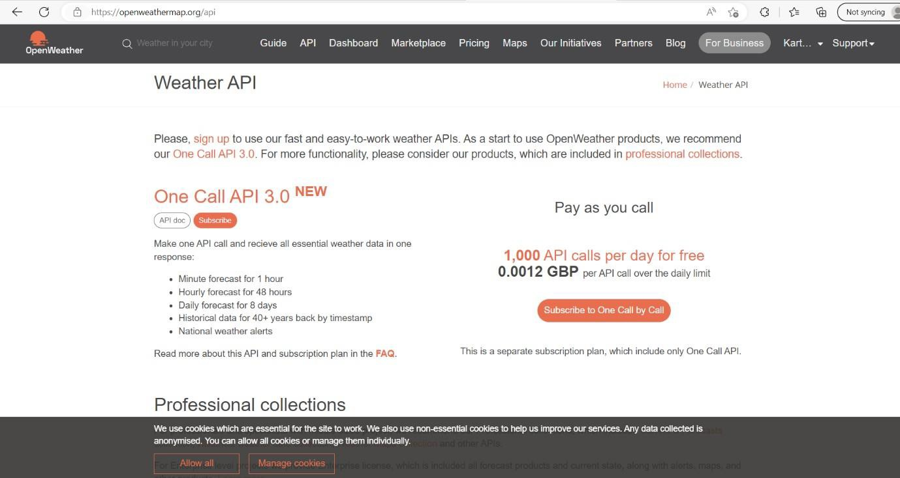

1. **Send the extracted data to the cloud**

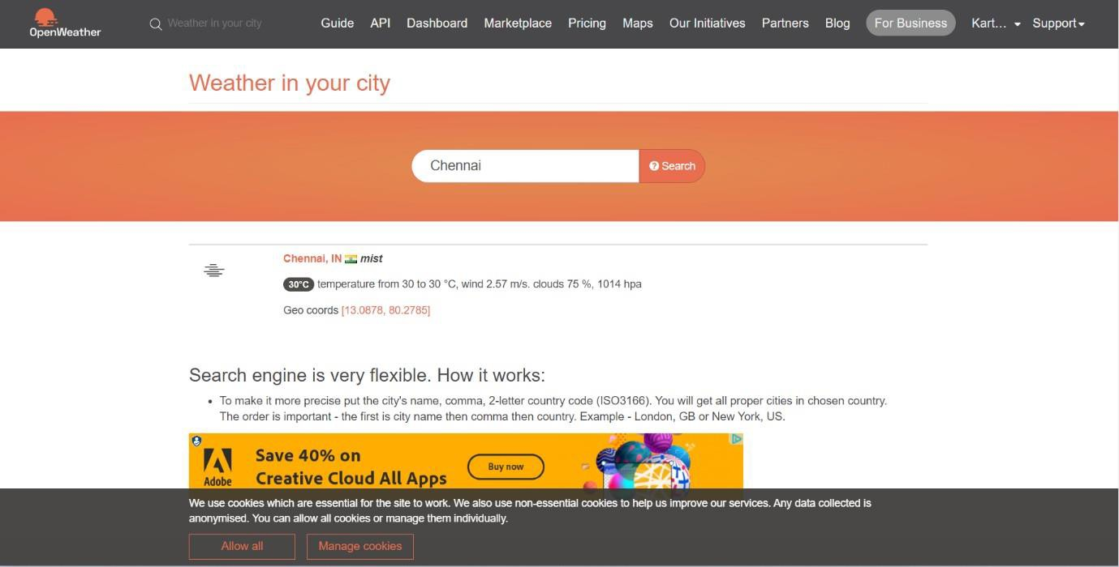

1. **Receive data from the cloud and view it in the python compiler**

